Module 1 – Foundation

1. What is a HTTP?

* HTTPS (Hypertext Transfer Protocol Secure) is a secure version of HTTP that encrypts data between a browser and a website. It's used to protect users' privacy and sensitive information.
* HTTPS is important because it: Prevents unauthorized parties from intercepting or tampering with data, Protects users' privacy, Prevents man-in-the-middle attacks, Prevents eavesdropping and tampering, and Authenticates the website.
* You can set your browser to HTTPS-only mode so that it always tries to visit websites over a secure connection first.

1. What is a Browsers? How they works?

* A web browser is a software application that allows users to access and view information on the World Wide Web. It retrieves web pages, displays text, images, and videos, and enables user interaction with online content. Browsers work by requesting web pages from servers, processing the received data (like HTML, CSS, and JavaScript), and displaying the content on the user's device.
* 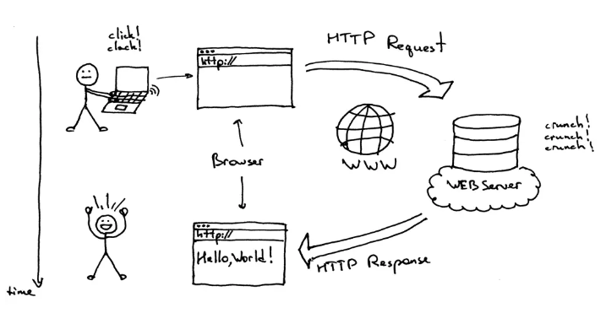
* 1. User Input: The user initiates the process by entering a website address (URL) or clicking a link in the browser.
* 2. Requesting the Web Page: The browser sends a request to the server hosting the web page. This request is typically sent using the Hypertext Transfer Protocol (HTTP).
* 3. Server Response: The server responds by sending back the web page's content, including HTML, CSS, JavaScript, images, and other resources.
* 4. Processing and Rendering: The browser receives the data and uses a rendering engine to parse the HTML, CSS, and JavaScript. It also handles the display of images, videos, and other multimedia content.
* 5. User Interaction: The user can interact with the displayed web page through various actions like clicking on links, scrolling, filling out forms, and more.
* In essence, the browser acts as a client-server program, requesting information from a server (the website) and displaying it to the user on their device.

1. What is Domain Name?

* a domain name is the text that a user types into a browser window to reach a particular website. For instance, the domain name for Google is ‘google.com’.

1. What is hosting?

* Hosting, in the context of the internet, is a service that allows you to store your website's files (like images, code, and text) on a server, making your website accessible to users online.
* How it works:

When someone visits your website, their browser requests the files from the server where your website is hosted. The hosting provider ensures that the server is up and running, secure, and that the files are transferred to the user's browser.

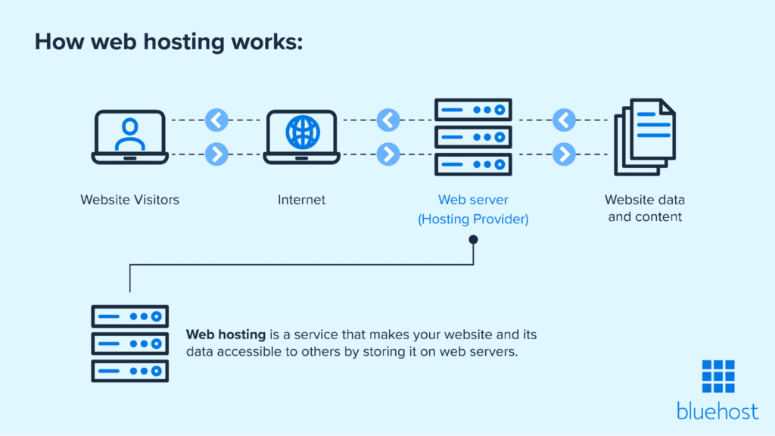

* Web hosting allows users to store content offsite, reducing local storage costs and the associated physical footprint. It also makes it easier to build a genuinely durable web presence, with built-in advantages like back-ups for security and support.

Module 2 – Fundamentals of World Wide Web

1. Difference between Web Designer and Web Developer

* Web design focuses on the visual appearance and user experience of a website, while web development focuses on the technical aspects, including coding and building the website's structure and functionality.
* Web Design:
* **Focus:** Visual aesthetics, user interface, and overall user experience.
* **Responsibilities:** Creating layouts, color schemes, typography, and other visual elements.
* **Skills:** Design software (Adobe Photoshop, Illustrator, Sketch), understanding of user interface (UI) and user experience (UX) principles.
* **Goal:** Enhance the website's appearance and usability.
* Web Development:
* **Focus:** Technical aspects, coding, and building the website's functionality.
* **Responsibilities:** Writing code (HTML, CSS, JavaScript, etc.), creating the website's structure and back-end, and ensuring the website works correctly.
* **Skills:** Programming languages, web technologies, understanding of databases and servers.
* **Goal:** Convert designs into a functional and working website.

1. What is a W3C?

* The World Wide Web Consortium (W3C) is an international community and organization that sets standards for the Web. Founded in 1994 by Tim Berners-Lee, the inventor of the Web, W3C works with member organizations, a full-time staff, and the public to develop web technologies and ensure the long-term growth and interoperability of the Web.
* W3C establishes standards for various aspects of the Web, including HTML, CSS, JavaScript, and more.
* W3C standards ensure that web pages look and function as expected across different browsers and devices, which is crucial for a consistent user experience.
* By providing a well-defined set of standards, W3C makes it easier for developers to create web applications and websites. W3C provides a platform for industry leaders to collaborate on new web technologies, driving innovation in the field.

1. What is Domain?

* A domain, in the context of the internet, is a unique name that identifies a website. It's the address you type into a browser to visit a specific webpage. Essentially, it's a human-readable version of an IP address, which computers use to communicate with each other.
* A domain is like a street address for the internet. It's the part of a website's address that comes before the top-level domain (like .com, .org, etc.).
* How it works:

When you type a domain into your browser, the Domain Name System (DNS) translates it into the corresponding IP address, which allows your computer to connect to the website's server.

* Domain names make the internet easier to navigate because they are easier to remember and type than complex numerical IP addresses.
* Examples:

google.com

wikipedia.org

example.com

1. What SEO?

* SEO, short for Search Engine Optimization, is the practice of improving a website's visibility in search engine results pages (SERPs) like Google, Bing, and Yahoo. The goal is to increase organic (unpaid) traffic to the site by optimizing its content and structure to align with search engine algorithms, making it easier for users to find relevant information.
* Increases visibility:

SEO helps websites rank higher in search results, making them more discoverable by potential visitors.

* By appearing prominently in search results, websites attract more visitors who are actively searching for information related to their content.
* Optimize title tags and meta descriptions: These are the snippets that appear in search results and are crucial for attracting clicks.
* Optimize content for target keywords: Use relevant keywords naturally within your website's content, but avoid keyword stuffing.
* Improve website structure and navigation: Search engines prefer well-organized and easy-to-navigate websites.
* Optimize images: Use descriptive alt tags and compress images to improve website loading speed.
* Improve website speed: Faster loading times are a ranking factor and enhance user experience.

1. What is SDLC life cycle?

* The Software Development Life Cycle (SDLC) is a structured process for building and maintaining software, encompassing all stages from initial planning to deployment and ongoing maintenance. It provides a framework for developers to plan, define, design, build, test, deploy, and maintain new software.
* **Structured Approach:** SDLC offers a systematic way to manage software development projects.
* **Phased Development:** It breaks down complex projects into manageable phases.
* **Efficiency and Quality:** SDLC aims to produce high-quality, cost-effective software efficiently.
* **Continuous Improvement:** It emphasizes ongoing maintenance and updates to ensure software remains effective and meets evolving needs.
* 